**SEARCH AND STORE STUDENT DATA IN MS ACCESS**

**PROGRAM**

Imports System.Data.OleDb

Public Class **WebForm1**

Inherits System.Web.UI.Page

Dim con As OleDbConnection

Dim cmd As OleDbCommand

Dim rd As OleDbDataReader

Protected Sub Page_Load(ByVal sender As Object, ByVal e As System.EventArgs) Handles Me.Load

con = New OleDbConnection("Provider=Microsoft.Jet.OLEDB.4.0;Data Source='D:\sample.mdb'")

con.Open()

cmd = New OleDbCommand("select * from student", con)

rd = cmd.ExecuteReader()

If Not Page.IsPostBack Then

While rd.Read()

DropDownList1.Items.Add(rd("Stud_Regno"))

End While

End If

Label1.Text = ""

con.Close()

End Sub

Private Sub Button1_Click(sender As Object, e As EventArgs) Handles Button1.Click

TextBox1.Text = ""

TextBox2.Text = ""

TextBox3.Text = ""

TextBox4.Text = ""

Label1.Text = ""

End Sub

Private Sub Button2_Click(sender As Object, e As EventArgs) Handles Button2.Click

Dim s As String

con.Open()

s = "insert into student values(" & TextBox1.Text & ",'" & TextBox2.Text & "','" & TextBox3.Text & "'," & TextBox4.Text & ")"

cmd = New OleDbCommand(s, con)

cmd.ExecuteNonQuery()

Label1.Text = "Record Stored Successfully"

TextBox1.Text = ""

TextBox2.Text = ""

TextBox3.Text = ""

TextBox4.Text = ""

DropDownList1.Items.Clear()

cmd = New OleDbCommand("select * from student", con)

rd = cmd.ExecuteReader()

While rd.Read()

DropDownList1.Items.Add(rd("Stud_Regno"))

End While

con.Close()

End Sub

Private Sub DropDownList1_SelectedIndexChanged(sender As Object, e As EventArgs) Handles DropDownList1.SelectedIndexChanged

Dim s1 As Int16

Dim s2 As String

con.Open()

s1 = DropDownList1.SelectedItem.Text

s2 = "select * from student where Stud_Regno=" & s1.ToString()

cmd = New OleDbCommand(s2, con)

rd = cmd.ExecuteReader()

rd.Read()

TextBox1.Text = rd("Stud_Regno")

TextBox2.Text = rd("Stud_Name")

TextBox3.Text = rd("Dept_Name")

TextBox4.Text = rd("Marks")

rd.Close()

End Sub

End Class

**MS Access**

DataBase Name: sample.mdb

Tabel Name : student

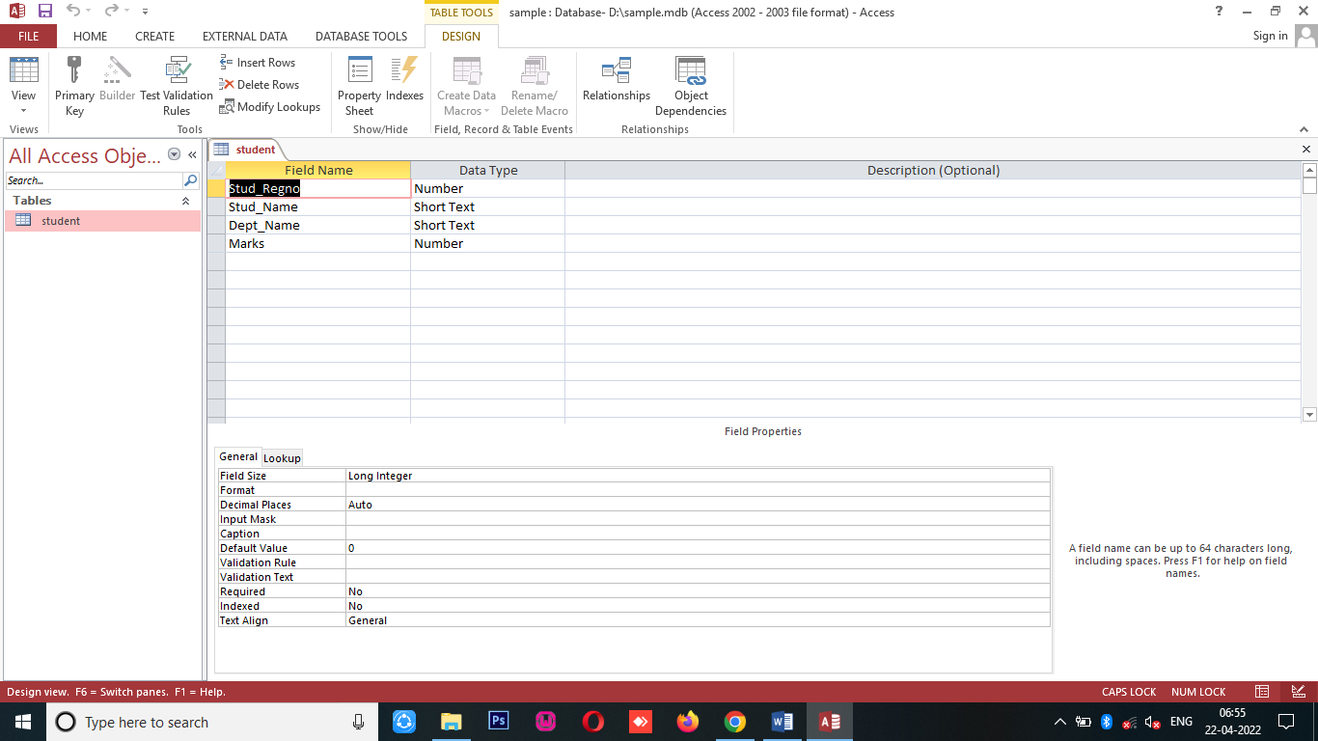

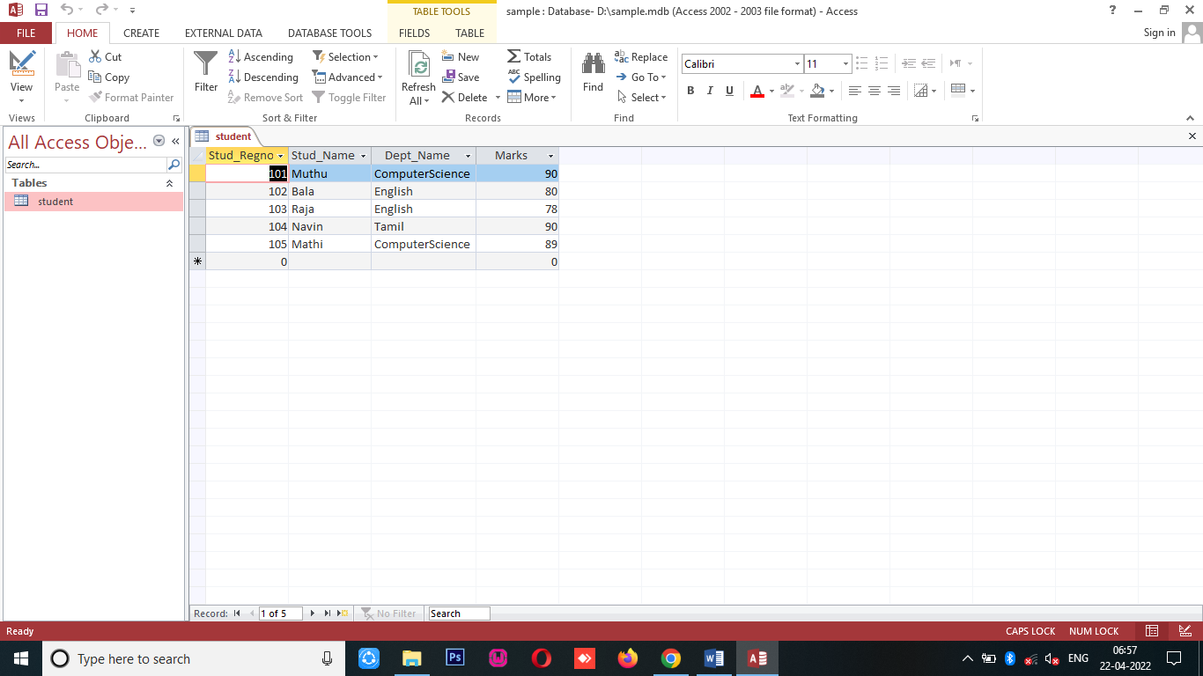

**OUTPUT**

